**COMPUTER NETWORKS - CSA07**

**Parthibhan .R**

**192224275**

**EXPRIMENT :-**

1.Transport layer protocol header analysis using Wireshark- TCP  
  
2. Network layer protocol header analysis using Wireshark - SMTP  
  
3. Network layer protocol header analysis using Wireshark - ICMP  
  
4. Transport layer protocol header analysis using Wireshark - UDP  
  
5. Network layer protocol header analysis using Wireshark - ARP  
  
6. Network layer protocol header analysis using Wireshark - HTTP  
  
7. Identify and monitor the IP, network address, Trace the router  
information, how to take remote system and Check the node connection  
 in network.  
  
8. Demonstration of PING operation using ICMP in Wireshark  
  
9. Configuration of firewall in packet tracer.  
  
10. Implementation of Bit stuffing mechanism using C

1.TCP wireshark:-

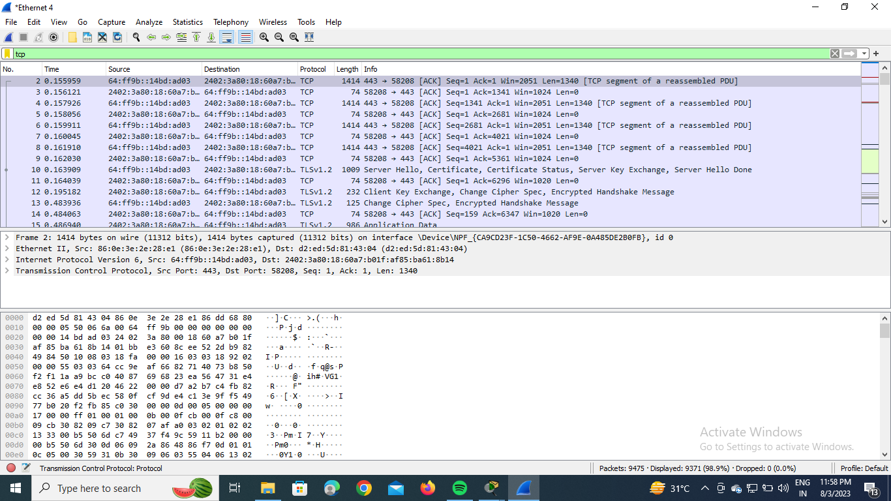

2.ICMP:-

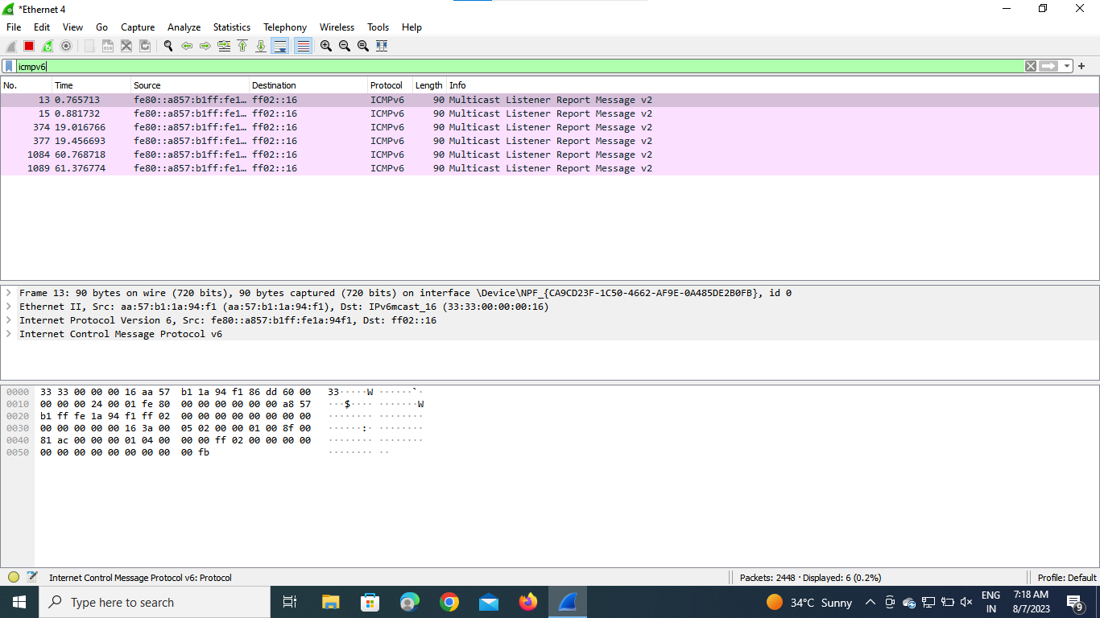

3.UDP:-

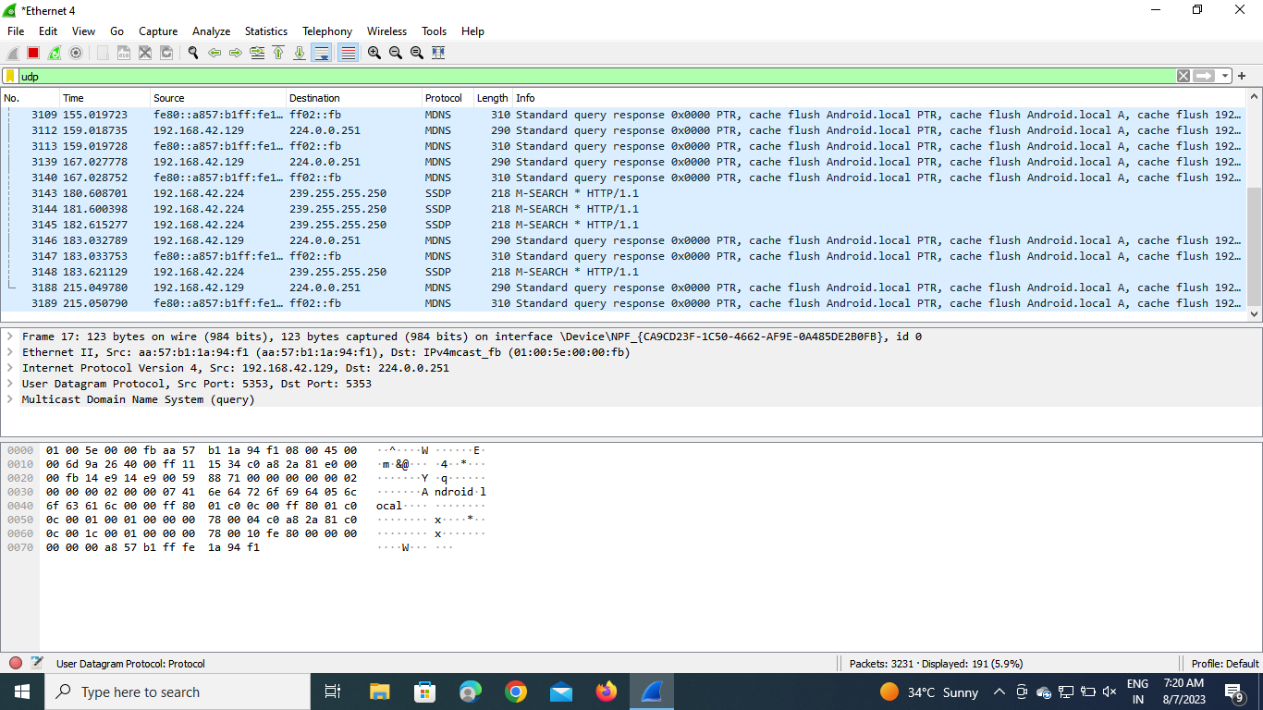

4.ARP:-

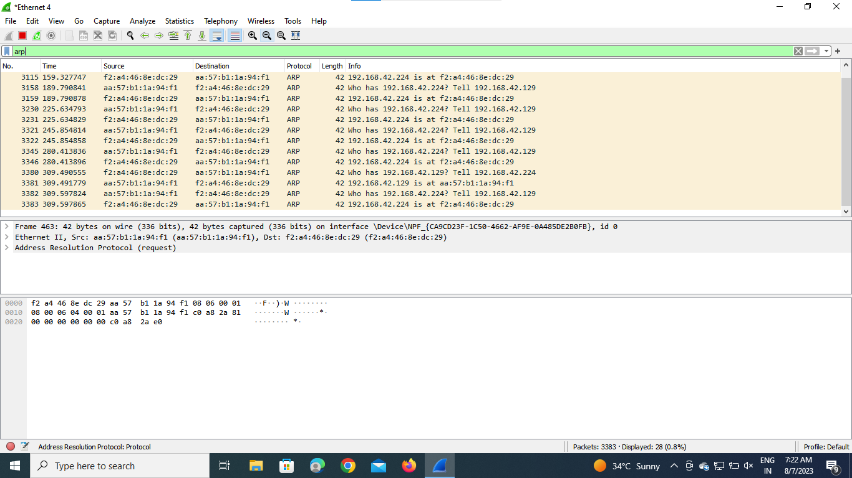

5.HTTP:-

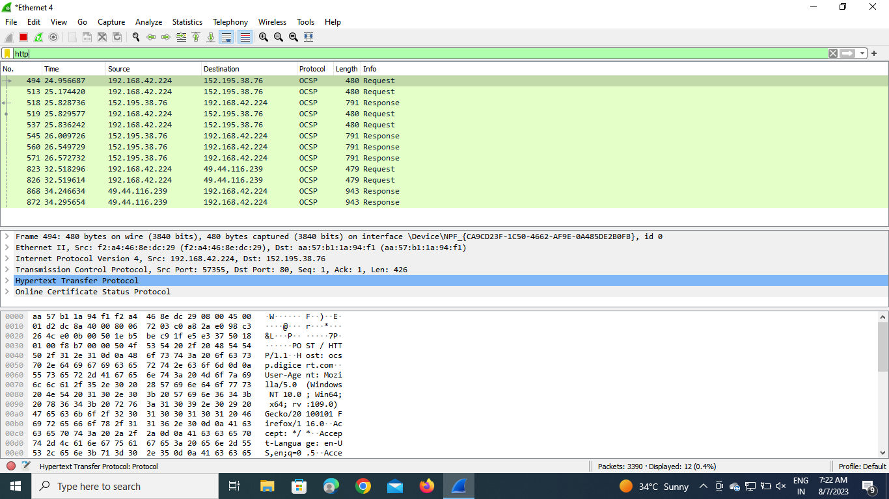

6. Implementation of Bit stuffing mechanism using C

